**Actual budget Consumtion for Civil**

Distributed budget for Civil work = 1979277/-

Actul consumed budget for services =833865 with additional Pedustals and hume pipe work.

Actul consumed budget for Materials =1093308

Total Consumed for Civil work =1927173 /-

Additional work done on project = 155704/-

Hence actual consumed budget is = 1771469/-

Total saving of budget in % = 2.63% without reducing additional work.

Total saving of budget in % = 10.49% by reducing additional work cost

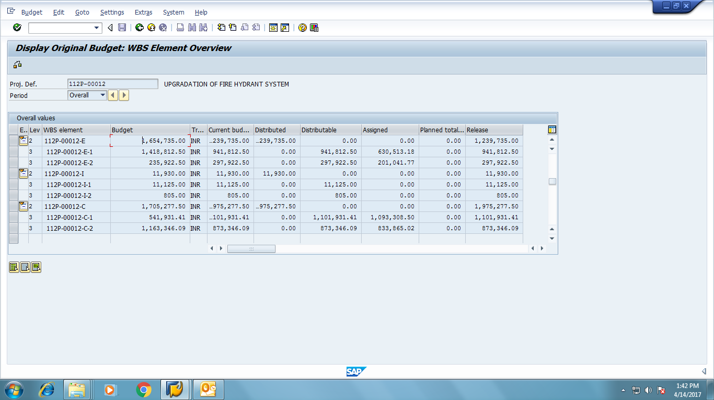

|  |  |  |  |  |
| --- | --- | --- | --- | --- |
| **Status Report on Fire Hydrant Up gradation project, Daman** | | | |  |
| **Fire Hydrant system Piping work** | | **Status as on 06.12.2016** | **Target date of Completion** | Remark. 11.01.2017 |
| Dettol Building |  |  |  |  |
|  | Ground Floor | Work is in progress. 70% completed | 08.12.2016 | completed pipe line but draine line , spikler, colour work as on work not comleted 11.01.2017 |
|  | First Floor | Will be released on 13.12.2016 | 13.12.2016 |
|  | Second Floor | Work is in progress. 40% completed | 06.12.2016 |
|  | Risers | Work is in progress. 20% completed | 17.12.2016 | done but painting work pending. |
| J&J Building |  |  |  |  |
|  | Ground Floor | Expected to start work from 17.12.2016 | 21.12.2016 | painting, sprikler,clamping on hydrant line pending. 11.01.2017 |
|  | First Floor | Not required in this area |  |
|  | Second Floor | Expected to start work from 22.12.2016 | 24.12.2016 |
|  | Risers | Expected to start work from 25.12.2016 | 29.12.2016 |
| Ring Header |  |  |  | work going. 11.01.2017 |
|  | Connectivity to Pump House | Yet To start. Expected to start 21.12.2016 | 23.12.2016 | not done 11.01.2017 |
|  | Suction & Discharge Header | Yet To start. Expected to start 21.12.2016 | 23.12.2016 | not done.11.01.2017 |
| Painting |  |  |  | panding.08.01.2017 |
|  | Dettol Building | Yet To start. Expected to start 18.12.2016 | 22.12.2016 | panding.08.01.2017 |
|  | J & J Building | Yet To start. Expected to start 23.12.2016 | 27.12.2016 | panding.08.01.2017 |
|  | Ring Header | Yet To start. Expected to start 28.12.2016 | 31.12.2016 | panding.08.01.2017 |
| Sprinkler Fitting |  |  |  |  |
|  | Dettol Building | Yet To start. Expected to start 18.12.2016 | 22.12.2016 | work pending. 11.01.2017 |
|  | J & J Building | Yet To start. Expected to start 23.12.2016 | 27.12.2016 | work pending. 11.01.2017 |
| Pump House |  |  |  | work pending. 11.01.2017 |
|  | Power Pump | Yet To start. Expected to start 21.12.2016 | 23.12.2016 | work pending. 11.01.2017 |
|  | Jockey Pump | Yet To start. Expected to start 21.12.2016 | 23.12.2016 | work pending. 11.01.2017 |
|  | Engine Driven Pump | Yet To start. Expected to start 21.12.2016 | 23.12.2016 | work pending. 11.01.2017 |
| **Smoke detector system Work** | |  |  |  |
| Dettol Building |  |  |  |  |
|  | Ground Floor | Completed |  |  |
|  | First Floor | Completed |  |  |
|  | Second Floor | Completed |  |  |
| J&J Building |  |  |  |  |
|  | Ground Floor | Completed |  |  |
|  | First Floor | Completed |  |  |
|  | Second Floor | Completed |  |  |
| **PA System work** | |  |  |  |
| Dettol Building |  |  |  |  |
|  | Ground Floor | Completed |  |  |
|  | First Floor | Completed |  |  |
|  | Second Floor | Completed |  |  |
| J&J Building |  |  |  |  |
|  | Ground Floor | Completed |  |  |
|  | First Floor | Completed |  |  |
|  | Second Floor | Completed |  |  |
| **Electrical System work** | |  |  |  |
|  | PA system cabling | Completed |  |  |
|  | PA system Panel | Yet To start | 12.12.2016 | completed trial to be given on 15.12.2016. |
|  | Smoke detection system cabling | Completed |  |  |
|  | Smoke detector panel | Yet To start | 12.12.2016 | completed. |
|  | Pump Connections | Yet To start. Expected to start 21.12.2016 | 23.12.2016 | work pending. 11.01.2017 |
|  | Pump Panel | Yet To start. Expected to start 21.12.2016 | 23.12.2016 | work pending. 11.01.2017 |
|  | Earthling system | Yet To start. Expected to start 21.12.2016 | 23.12.2016 | done . |
| **Civil Work** | |  |  |  |
|  | Tank Foundation | Completed. Under curing till 09.12.2016 | going. | work comlited. 0801.2017 |
|  | Pump Foundation | Work in progress. 30% completed | 12.12.2016 |
|  | Earth Filling | Yet To start | 14.12.2016 |
|  | Compaction | Yet To start | 17.12.2016 |
|  | Soling | Yet To start | 19.12.2016 |
|  | PCC | Yet To start | 20.12.2016 |
|  | Brick work | Yet To start | 21.12.2016 |
|  | Finishing | Yet To start | 27.12.2016 |
|  | Railing | Need based |  | work pending. 11.01.2017 |
|  | Painting |  | 10.01.2017 | work pending. 11.01.2017 |
| **Equipment Installation** | |  |  |  |
| Tank | Expected start date | Material received. Expected to start from 08.12.2016 | Not start. On 08.12.2016 | water lavel indicator & lead cove pending. 11.01.2017 |
|  | Expected end date | 15.12.2016 |  |  |
| Power Pump | Expected start date | 13.12.2016 | Not start. On 13.12.2016 | water tank to pump & hydrant line connection pending. |
|  | Expected end date | 15.12.2016 | Not start. On 15.12.2016 | water tank to pump & hydrant line connection pending. |
|  |  |  |  |  |



**Sigma Engineering Solutions**

1030/1 Akashganga Society, Shivajinagar, PUNE – 411016, [TEL : 020-25673460](TEL:020-25893460)



20 Dec 2016

CERTIFICATE OF STABILITY

Form-1A (Rule-3A)

1. Name of Factory : VVF (India) Limited
2. Village, Town, district in

which the factory is situated : Daman

1. Full Postal address of the factory : Plot No. 141/143, Survey No. 195/4 195/6 Panchal Udyog Nagar, Bhimpore, Nani Daman 396210.

1. Name of the occupier of the factory : Mr. Dinesh Kabra
2. Nature of manufacturing process : Fire Water Tank Supporting Structure be carried on in the factory

1. Number of floors on which the

workers will be employed : Ground Floor

I certify that, I have inspected the premises, the plans of which have been approved by the Jt. Director Industrial Safety & Health- Raigad vide his Letter No. JDISH/PLN/R-143-2015/SPR/2684/Raigad Dated 24/09/2015 and examined the various parts including the foundation that have been installed.

I am of the opinion, that all the tank supporting structure constructed in the premises, is structurally sound and its stability will not be endangered by its use as water tank supporting structure.

Amit. Ghangurde

Qualification : B.E. (Civil)

Chartered Engineer No : M-141202-1